**AIM:**

Write a C program to check whether each number in a given set is odd or even.

**ALGORITHM:**

1. Start the program.
2. Input the total number of elements (n).
3. Input the set of n numbers.
4. For each number, check if it is divisible by 2.
5. If divisible, print “Even”, else print “Odd”

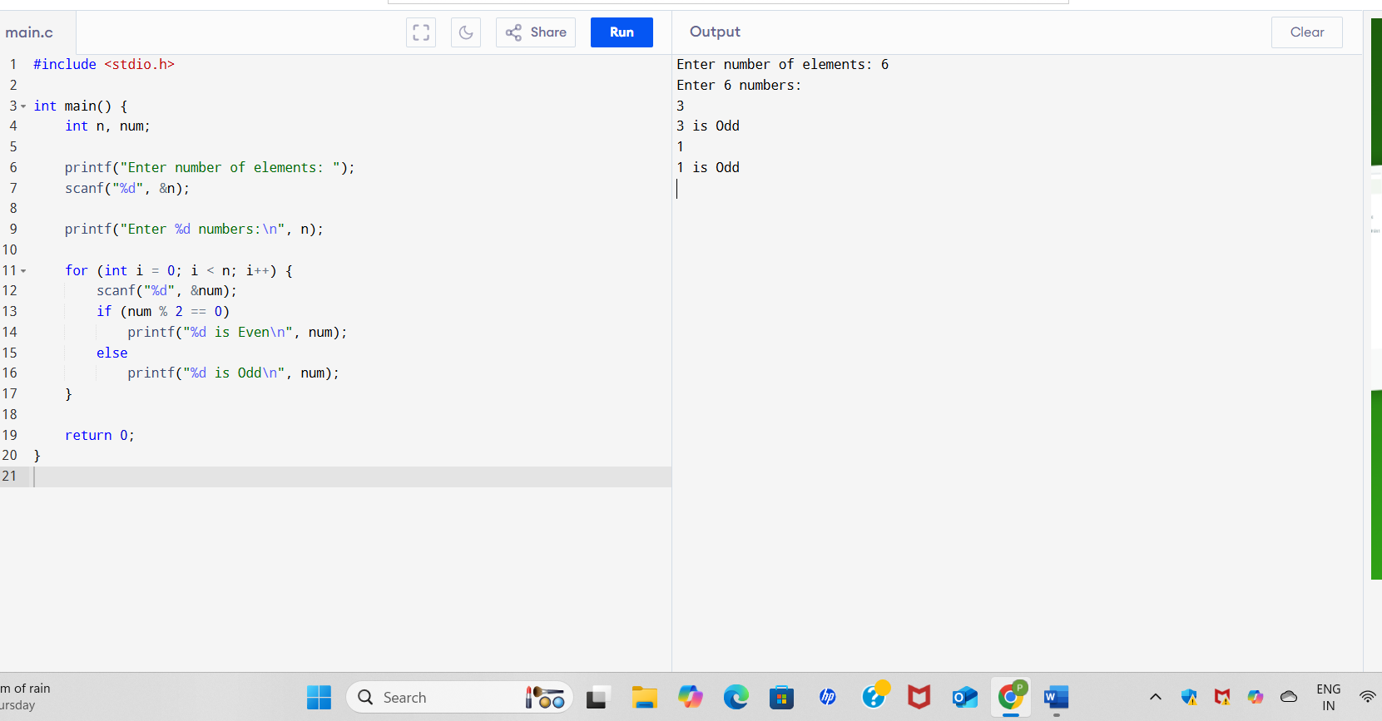

SAMPLE OUTPUT

Enter number of elements: 5

Enter 5 numbers:

12

7

9

20

33

12 is Even

7 is Odd

9 is Odd

20 is Even

33 is Odd

**RESULT:**

The program successfully identifies and displays whether each input number is odd or even.